**ABOUT DAY -0**

**One.c-**

Write a program to find the roots of the quadratic equation.  
Give the different values of a,b and c to find the all possible roots.

**Two.c-**

Use of switch to print division with multiple entries using for loop atleast 10 entries.

**Three.c-**

**// Write a C- code to print**

**// (i) Prime numbers between 1 to N. (N= 200),**

**(ii) First N prime numbers. (N=20).**

**Four.c-**

**// FITTING A EXPONENTIAL FUNCTION WITH PARAMETER THETA=1.5**

**// PLOTTING A EXPONENTIAL FUNCTION**

**Five.c-**

**Write a code to read the following array of size 35.**

**11.2,16.0,16.3,17.9,11.3,11.4,8.6,12.0,17.5,12.9,8.8,10.5,18.0,8.3,10.7,10.8,11.0,11.0,11.1,**

**20.6,11.4,12.9,13.3,13.7,13.8,14.0,14.2,14.5,17.3,11.7,18.0,12.5, 15.6,20.4,22.3.**

**Calculate its Mean, Median ,Variance and s.d.Use file to input and output data.**

**Six.6-**

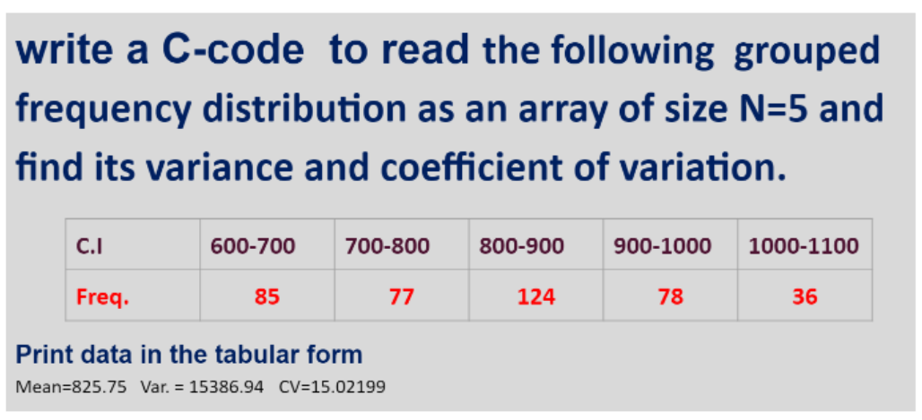

**Seven.c-**

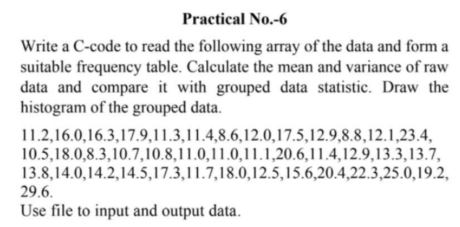

**eight.c-**

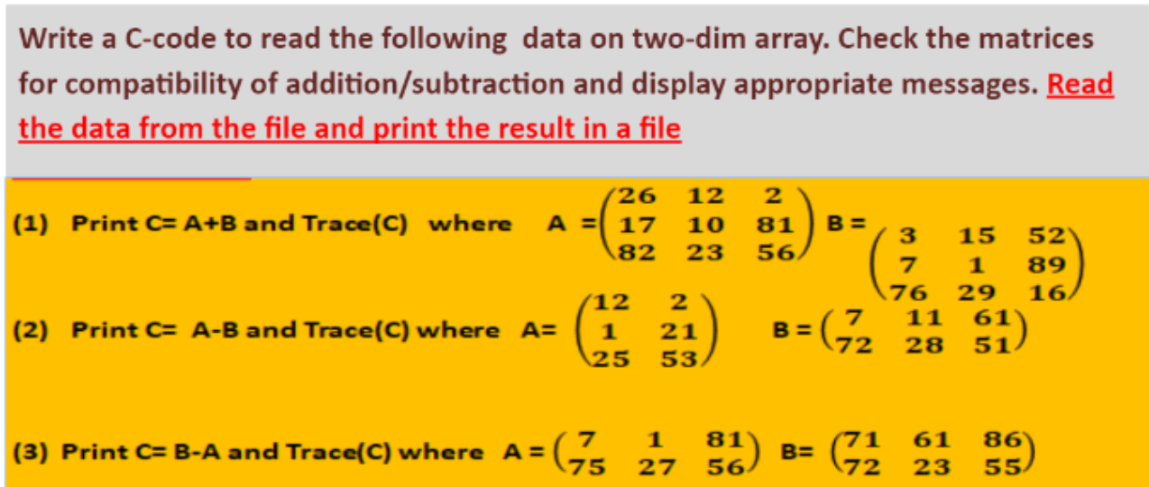

**Nine.c-**

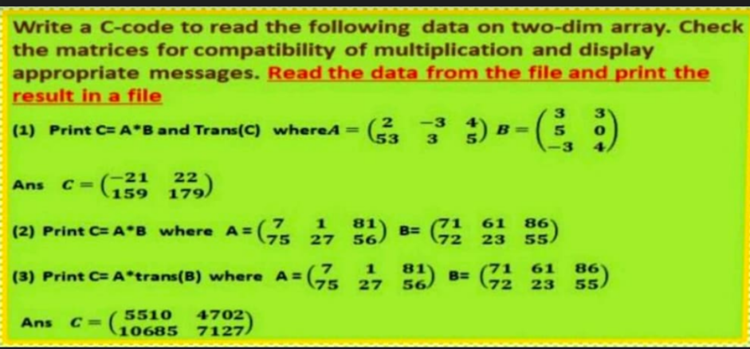

**Ten.c**

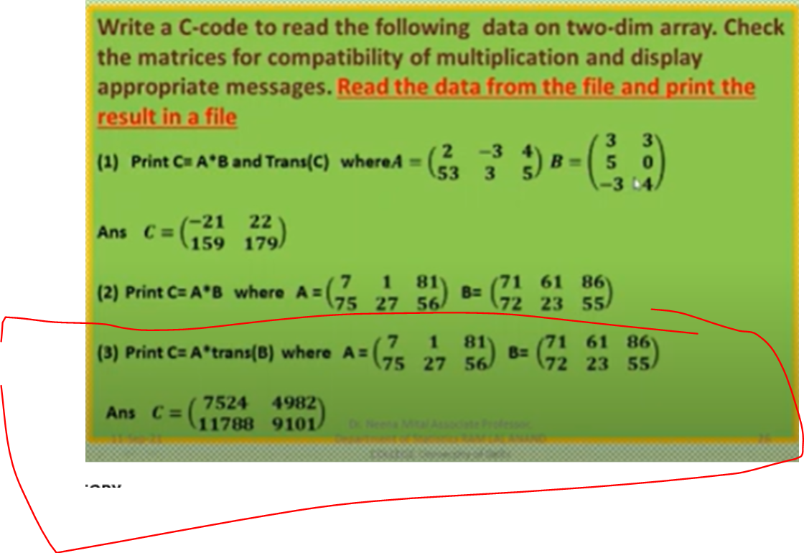

**Eleven.c-**

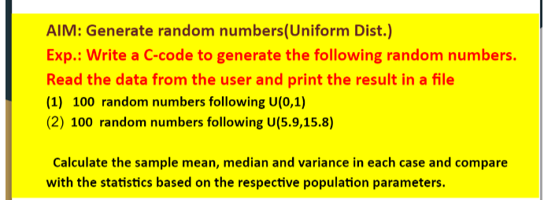

**Twelve.c**

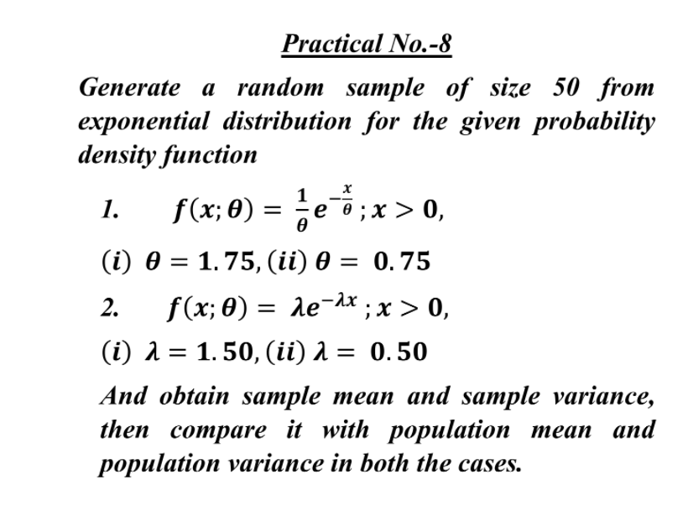

**Thirteen.c-**

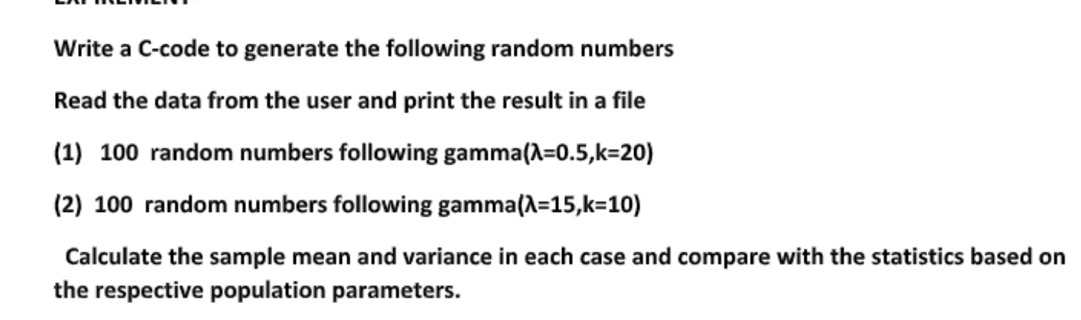

**Fourteen.c-**

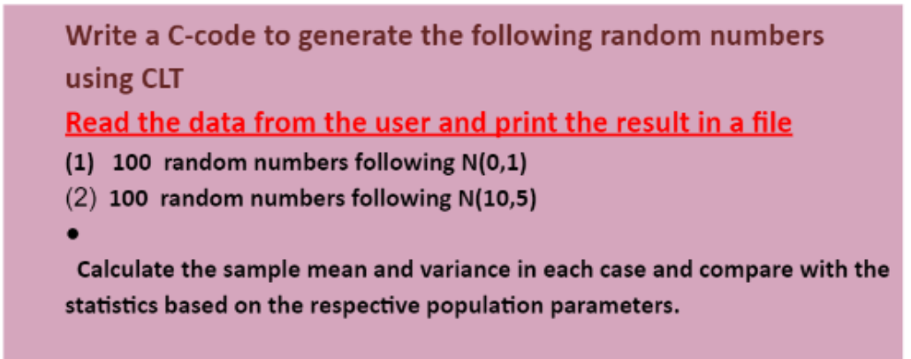

**Fifteen.c-**

**Write a program to generate a random sample of size 50 from chi-square distribution, where**

**random numbers from normal distribution is generated by Box-Muller method.**

**Sixteen .c-**

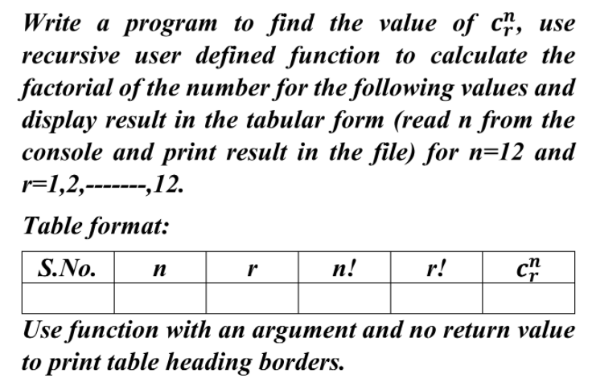

**Seventeen.c-**

